You are a venture capitalist. Calculate the Profit Margin for the startup whose income statement is shown below.

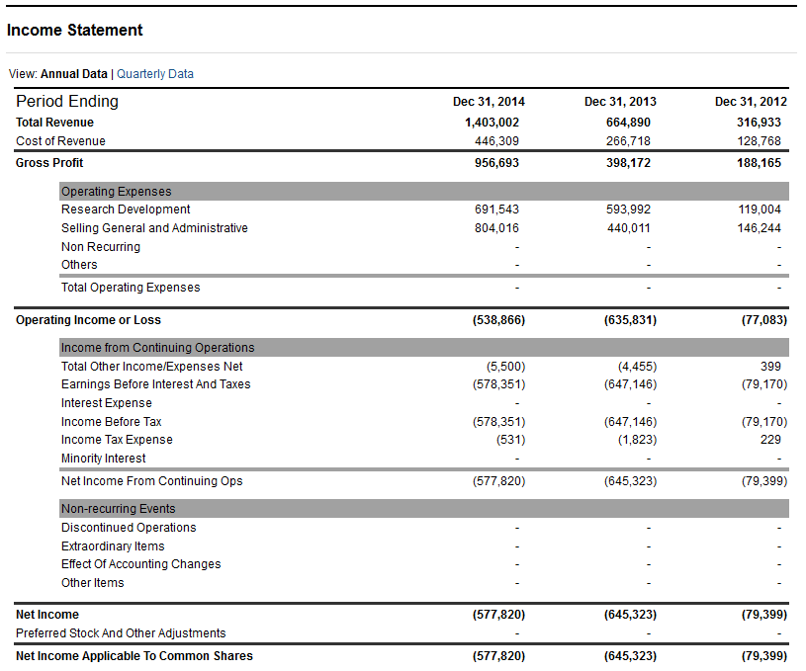

As the VC looking to invest discuss what this number means, why might this number be low and why you still might invest (or not invest).

An entrepreneur decides to invest 1.2 million for a 20% stack in your business. What valuation does this put on your business? (Show work)